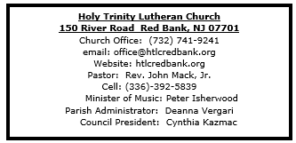
- Greetings and welcome! Angels and Archangels are rejoicing before the throne of God that you have found your way here this day!
- As we gather in this sanctuary and joyfully greet one another, may we also be sensitive to those preparing for worship through silent meditation or by listening to the choir.
- All are invited to share in the Lord's Supper receiving Christ's presence through the ministration of bread and wine. As you come forward, you may receive wine from the pouring chalice (take a small glass from the tray as you approach the communion rail) or common cup. Grape juice is distributed at the communion rail if you prefer it instead. Gluten free communion is available upon request.
- Should you need communion brought to your seat, let the usher know.
- Children are encouraged to participate in the lively movement of worship as they are able.If instead, or at any point in the service your child desires to go to the nursery, it is located across the hall through the double doors of the church in the East transept (the shorter wing of the church). The nursery is for children through age 4.
- Bathrooms are located on the ground floor of the East transept (the shorter wing of the church).
- If this is your first time to worship at Holy Trinity Lutheran Church, please sign our guest book, including your name, address and phone number. Guest books are located at both entrances.
- After worship, please come downstairs for coffee (or tea) and informal fellowship.



December 14, 2025

Third Sunday of Advent

Introduction
A note of joyful expectation marks today’s worship. Isaiah announces that the desert shall rejoice and blossom, and Jesus points to the unexpected and transforming signs of God’s reign. We wait with patience for the coming of the Lord, even as we rejoice at his presence among us this day: in word and holy supper, in church and in our homes, in silent reflection and in works of justice and love. We pray that God would open our eyes and ears to the wonders of Christ’s advent among us.

Welcome & Announcements (Please silence your cell phone!)

Prelude (We prayerfully prepare our hearts and minds to worship!)

+ GATHERING +

Confession and Forgiveness
All may make the sign of the cross, the sign that is marked at baptism, as the presiding minister begins.
P: Blessed be the holy Trinity, ☩ one God,
whose home is heaven and earth,
whose salvation is sure.
C: Amen.
P: Let us confess our sin in the presence of God
and of one another.
Silence is kept for reflection.
Long-expected God,
C: we confess that we look to ourselves
for the peace and security only you can provide.
We reach for swords and spears,
reluctant to release our grip on the ways of war.
We become impatient while waiting
and weary of keeping awake.
Free us from self-reliance,
and teach us to live in harmony with our neighbors.
Increase our trust in God’s timing,
and awaken us to your advent among us,
that we may abound in the hope you have promised.
Amen.
P: God judges us not as we deserve,
but according to God’s own righteousness.
☩ You are freed and forgiven,
saved by grace,
and ready to welcome the Savior.
C: Amen.

*Gathering Hymn ELW 257 O Come, O Come, Emmanuel (v.5 & 6)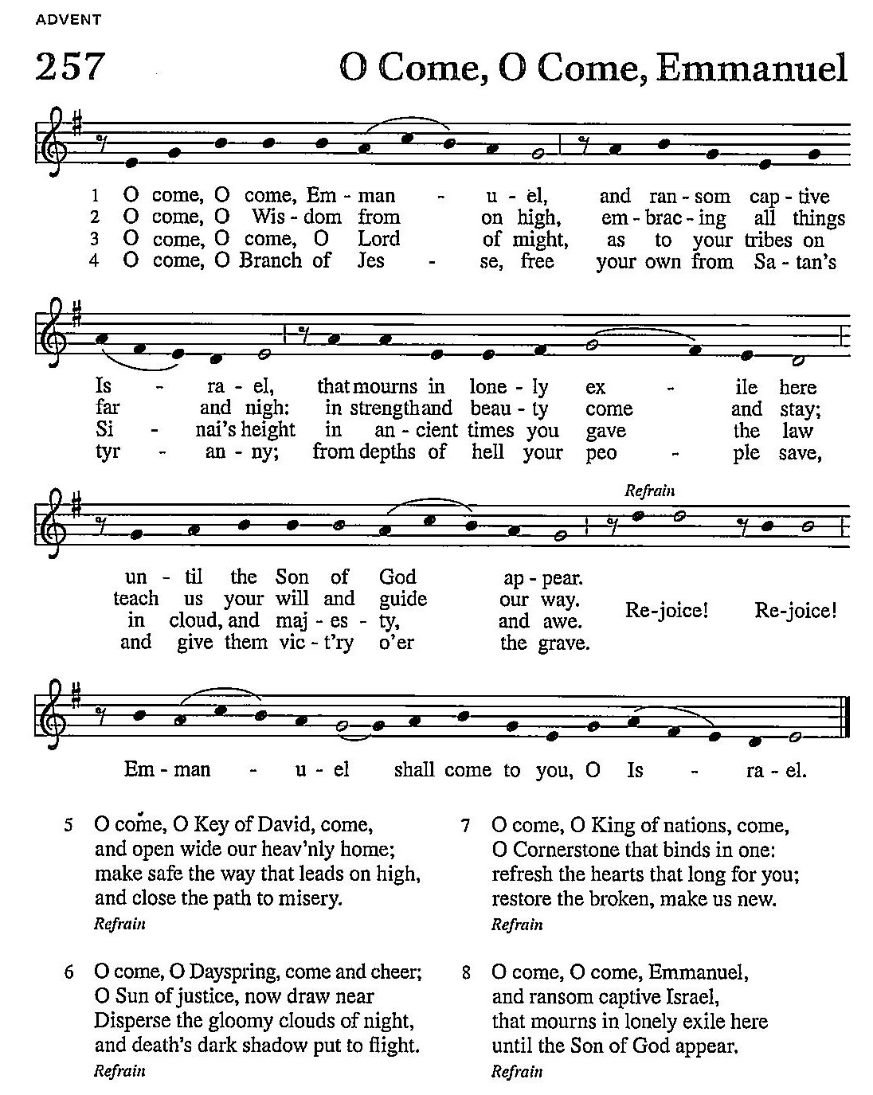

*Pastoral Greeting

P: The Grace and Peace of our Lord Jesus Christ, the love of God, and the communion of the Holy Spirit be with you all! C: And also with you!

Kyrie
Refer to the blue insert.

The Bennetts

Lighting the Advent Wreath: Week 3
We praise you, O God, for this victory wreath that marks our days of preparation for Christ’s advent. As we light the candles on this wreath, strengthen our hearts as we await the Lord’s coming in glory. Enlighten us with your grace, that we may serve our neighbors in need. Grant this through Christ our Lord, whose coming is certain and whose day draws near.
C: Amen

ELW 240 v. 3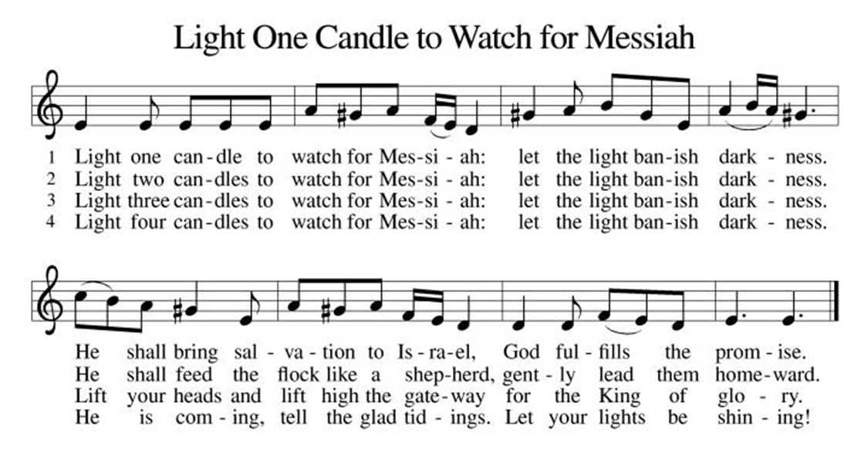

*Prayer of the Day
P: Stir up the wills of all who look to you, Lord God, and strengthen our faith in your coming, that, transformed by grace, we may walk in your way; through Jesus Christ, our Savior and Lord, who lives and reigns with you and the Holy Spirit, one God, now and forever. C: Amen!
+WORD+

First Reading: Isaiah 35:1-10
The prophet describes the return from the Babylonian captivity as a joyous procession to Zion. God’s coming reign will bring a renewal of creation in which health and wholeness will be restored. There is no need for fear, for God is coming to save.
¹ The wilderness and the dry land shall be glad;
the desert shall rejoice and blossom;
like the crocus ² it shall blossom abundantly
and rejoice with joy and shouting.
The glory of Lebanon shall be given to it,
the majesty of Carmel and Sharon.
They shall see the glory of the Lord,
the majesty of our God.]]
³ Strengthen the weak hands
and make firm the feeble knees.
⁴ Say to those who are of a fearful heart,
“Be strong, do not fear!
Here is your God.
He will come with vengeance,
with terrible recompense.
He will come and save you.”
⁵ Then the eyes of the blind shall be opened,
and the ears of the deaf shall be opened;
⁶ then the lame shall leap like a deer,
and the tongue of the speechless sing for joy.
For waters shall break forth in the wilderness
and streams in the desert;
⁷ the burning sand shall become a pool
and the thirsty ground springs of water;
the haunt of jackals shall become a swamp;
the grass shall become reeds and rushes.
⁸ A highway shall be there,
and it shall be called the Holy Way;
the unclean shall not travel on it,
but it shall be for God’s people;
no traveler, not even fools, shall go astray.
⁹ No lion shall be there,
nor shall any ravenous beast come up on it;
they shall not be found there,
but the redeemed shall walk there.
¹⁰ And the ransomed of the Lord shall return
and come to Zion with singing;
everlasting joy shall be upon their heads;
they shall obtain joy and gladness,
and sorrow and sighing shall flee away.

Psalm: Psalm Luke 1:46-55 “The Magnificant”
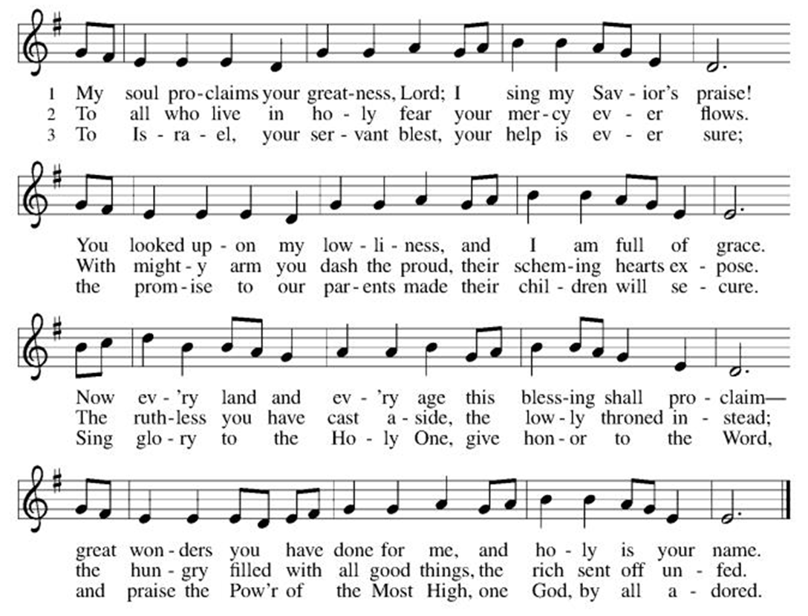

Second Reading: James 5:7-10

In anticipation of the Lord’s coming, Christians are called upon to cultivate patience rather than discontent.

⁷ Be patient, therefore, brothers and sisters, until the coming of the Lord. The farmer waits for the precious crop from the earth, being patient with it until it receives the early and the late rains. ⁸ You also must be patient. Strengthen your hearts, for the coming of the Lord is near. ⁹ Brothers and sisters, do not grumble against one another, so that you may not be judged. See, the Judge is standing at the doors! ¹⁰ As an example of suffering and patience, brothers and sisters, take the prophets who spoke in the name of the Lord.

*Gospel Acclamation
Refer to the blue insert
P: The Holy Gospel According to the St. Matthew the 11th Chapter
C: Glory to You, O Lord!

Gospel: Matthew 11:2-11
John the Baptist expects the Messiah to bring God’s judgment upon the earth (Matt. 3:11-12). From a prison cell, he wonders whether Jesus is the one who will do this. Jesus’ response indicates that God’s reign is indeed being fulfilled already through healing and restoration.

² When John heard in prison what the Messiah was doing, he sent word by his disciples ³ and said to him, “Are you the one who is to come, or are we to wait for another?” ⁴ Jesus answered them, “Go and tell John what you hear and see: ⁵ the blind receive their sight, the lame walk, those with a skin disease are cleansed, the deaf hear, the dead are raised, and the poor have good news brought to them. ⁶ And blessed is anyone who takes no offense at me.”
⁷ As they went away, Jesus began to speak to the crowds about John: “What did you go out into the wilderness to look at? A reed shaken by the wind? ⁸ What, then, did you go out to see? Someone dressed in soft robes? Look, those who wear soft robes are in royal palaces. ⁹ What, then, did you go out to see? A prophet? Yes, I tell you, and more than a prophet. ¹⁰ This is the one about whom it is written,
‘See, I am sending my messenger ahead of you,
who will prepare your way before you.’
¹¹ “Truly I tell you, among those born of women no one has arisen greater than John the Baptist, yet the least in the kingdom of heaven is greater than he.”

P: The Gospel of the Lord
C: Praise to you, O Christ!

Sermon
*Hymn of the Day ELW 246 Hark! A Thrilling Voice Is Sounding! (v.1-4)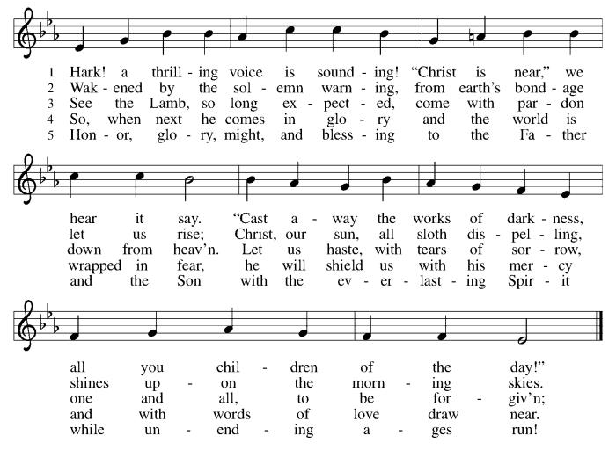

* Nicene Creed
We believe in one God,
the Father, the Almighty,
maker of heaven and earth,
of all that is, seen and unseen.
We believe in one Lord, Jesus Christ,
the only Son of God,
eternally begotten of the Father,
God from God, Light from Light,
true God from true God,
begotten, not made,
of one Being with the Father;
through him all things were made.
For us and for our salvation
he came down from heaven,
was incarnate of the Holy Spirit and the Virgin Mary
and became truly human.
For our sake he was crucified under Pontius Pilate;
he suffered death and was buried.
On the third day he rose again
in accordance with the Scriptures;
he ascended into heaven
and is seated at the right hand of the Father.
He will come again in glory to judge the living and the dead,
and his kingdom will have no end.
We believe in the Holy Spirit, the Lord, the giver of life,
who proceeds from the Father and the Son,
who with the Father and the Son is worshiped and glorified,
who has spoken through the prophets.
We believe in one holy catholic and apostolic church.
We acknowledge one baptism for the forgiveness of sins.
We look for the resurrection of the dead,
and the life of the world to come. Amen.

*Prayers of Intercession
In our waiting and watching, we come to you in prayer, O God, trusting your promise to renew the church, the nations, and the whole creation.
A brief silence.
God of power and mercy, we praise you for Jesus and his acts of healing and liberation. Lead us to proclaim the good news from generation to generation, that all may place their hope in you. God of grace,
C:hear our prayer.
When lands are parched and dry, bring rain and snow; where wilderness is barren, sow seeds of life. Fill the lands with trees that grow, plants that flower, and creatures that thrive, as nature proclaims the wonder of your works. God of grace,
C:hear our prayer.
When there is injustice or corruption among nations and leaders, root it out. Turn their attention to inequity and the cries of the poor. Instill a deeper sense of compassion and care in all who govern. God of grace,
C:hear our prayer.
When bodies weaken and hearts grow fearful, speak your blessing. (We pray especially for . . .) In uncertain times, remind us of the promise spoken to our ancestors in faith. God of grace,
C:hear our prayer.
When people are imprisoned or held captive, break the chains and offer release. Strengthen the work of the church in restorative justice, breaking cycles of poverty, and welcoming the immigrant (especially we pray for Global Refuge and Lutheran Social Services). God of grace,
C:hear our prayer.
Here other intercessions may be offered.
As we await your coming, we give thanks for the faithful who have lived and died in faith (especially Mary, mother of Jesus, John of the Cross and . . .). May their boldness of faith inspire our witness and work. God of grace,
C:hear our prayer.
Draw near to us, O God, as we commend all for whom we pray, trusting in your mercy through Jesus Christ, Emmanuel.
C: Amen.

Greeting of Peace
P: The peace of Christ be with you and those you love!
C: And also with you! (The peace is shared with all!)

Offering (Thank you for your support for our ministry!)

*Doxology ELW 246 Hark! A Thrilling Voice Is Sounding! (v.5)(Please stand and join in singing as we share our gifts!)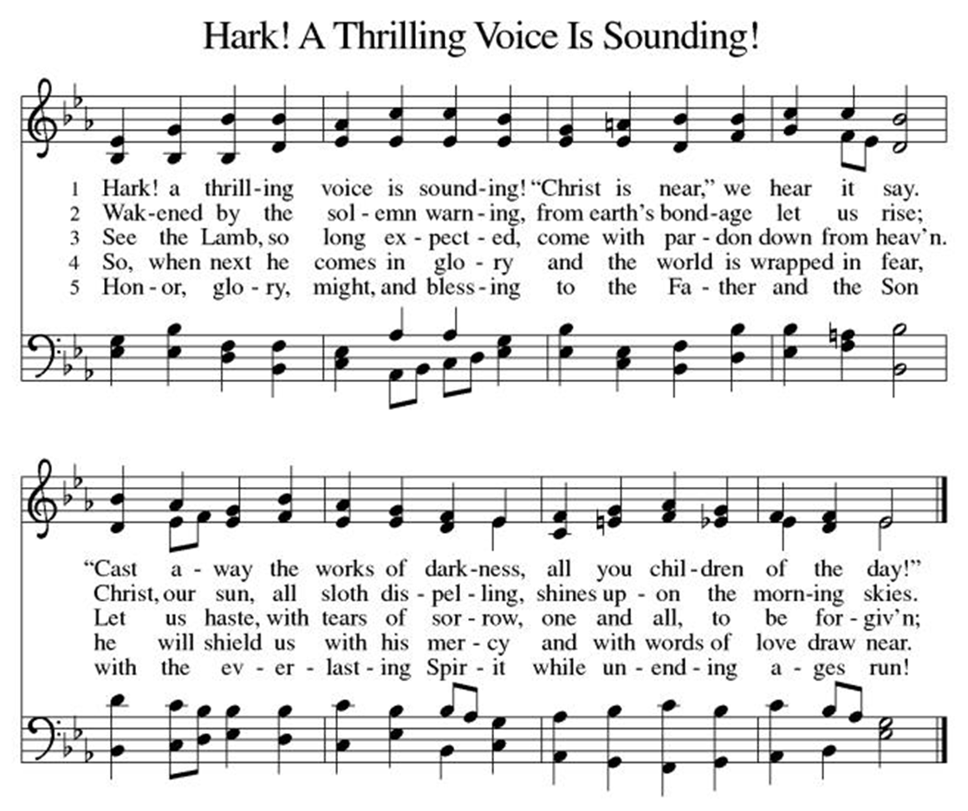*Offering Prayer
A: Nourishing God,
C: you are water in the wilderness and streams in the desert.
Through this meal, satisfy our parched places,
that we may rejoice and be for the world
signs of your kingdom come.
Amen.

+MEAL+
(All are welcome at the table of our Lord!)
*Great Thanksgiving
P: The Lord be with you.
C: And also with you.

P: Lift up your hearts.
C: We lift them to the Lord.

P: Let us give thanks to the Lord our God.
C: It is right to give our thanks and praise.

P: It is indeed right, our duty and our joy, that we should at all times and in all places give thanks and praise to you, almighty and merciful God, through our Savior Jesus Christ.
You comforted your people with the promise of the Redeemer, through whom you will also make all things new in the day when he comes to judge the world in righteousness. And so, with all the choirs of angels, with the church on earth and the hosts of heaven,
we praise your name and join their unending hymn:

*Sanctus
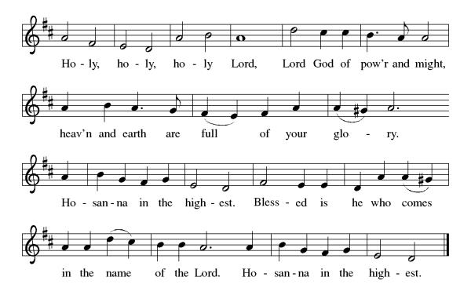

*Eucharistic Prayer
P: Holy One,
the beginning and the end, the giver of life:
Blessed are you for the birth of creation.
Blessed are you in the darkness and in the light.
Blessed are you for your promise to your people.
Blessed are you in the prophets’ hopes and dreams.
Blessed are you for Mary’s openness to your will.
Blessed are you for your Son Jesus,
the Word made flesh.

In the night in which he was betrayed,
our Lord Jesus took bread, and gave thanks;
broke it, and gave it to his disciples, saying:
Take and eat; this is my body, given for you.
Do this for the remembrance of me.

Again, after supper, he took the cup, gave thanks,
and gave it for all to drink, saying:
This cup is the new covenant in my blood,
shed for you and for all people for the forgiveness of sin.
Do this for the remembrance of me.

Let us proclaim the mystery of faith:
C: Christ has died. Christ is risen. Christ will come again.

P: With this bread and cup
we remember your Word dwelling among us,
full of grace and truth.
We remember our new birth in his death and resurrection.
We look with hope for his coming.
C: Come, Lord Jesus.

P: Holy God, we long for your Spirit.
Come among us.
Bless this meal.
May your Word take flesh in us.
Awaken your people.
Fill us with your light.
Bring the gift of peace on earth.
C: Come, Holy Spirit.
P:All praise and glory are yours,
Holy One of Israel,
Word of God incarnate,
Power of the Most High,
one God, now and forever.
C: Amen.

*THE LORD’S PRAYER
Our Father, who art in heaven,
hallowed be thy name,
thy kingdom come,
thy will be done,
on earth as it is in heaven.
Give us this day our daily bread;
and forgive us our trespasses,
as we forgive those
who trespass against us;
and lead us not into temptation,
but deliver us from evil.
For thine is the kingdom,
and the power, and the glory, forever and ever. Amen.

*Lamb of God
Refer to the blue insert

Spiritual Communion Prayer
P: Let us pray for the communion of all present here, those viewing our service virtually, those in our hearts and in our world.
C: Lord Jesus, I believe you are truly present in the Sacrament of Holy Communion. When I cannot receive Communion, I pray that you come into my heart. I know that nothing in Heaven or on earth can separate me from your love. Amen.

Invitation to Communion
P: Here is life. God is with us.
Come, receive what God has promised.

C: Thanks be to God.

(All are invited to the communion rail following the guidance of the ushers. Communion will be shared through the host and individual cups. If you would like communion but are unable to join us at the rail, please alert the usher!)

Communion Hymns (Please join in singing!)
ELW 465 As the Grains of Wheat
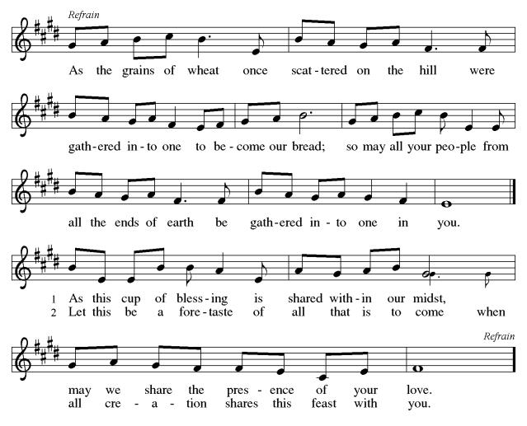
ELW 251 My Soul Proclaims Your Greatness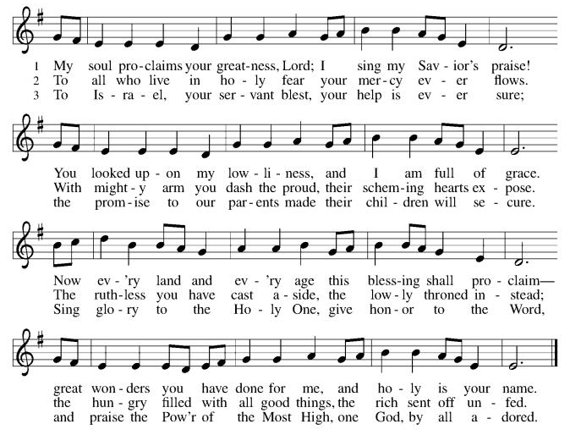

P: The body and blood of our Lord Jesus Christ strengthen you and keep you in his grace. C: Amen!

*Prayer after Communion
A: God our host,
at this table you have fed us with joy and gladness.
Send us forth, eager to share the feast,
welcome the stranger,
and bear good fruit in the name of Jesus.
C: Amen!

+Sending+

*Blessing
P: May God who comes among us,
Father, ☩ Son, and Holy Spirit,
grant you patience in waiting, peace in the darkness,
and good news to share today and always.
C: Amen!

*Sending Hymn ELW 253 He Came Down (v 1& 2)
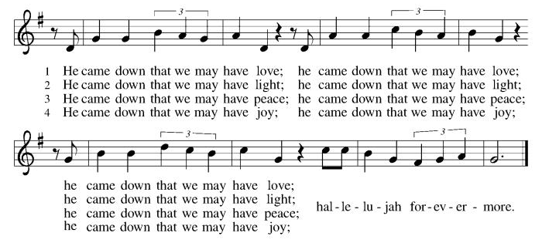

*Dismissal
A: Go in peace. Keep awake.
C: Thanks Be to God.

Postlude

Copyright © 2020 Augsburg Fortress. All rights reserved. Reprinted by permission under Augsburg Fortress Liturgies Annual License #SB106907. New Revised Standard Version Bible, Copyright © 1989, Division of Christian Education of the National Council of the Churches of Christ in the United States of America. Used by permission. All rights reserved. Revised Common Lectionary, Copyright © 1992 Consultation on Common Texts, admin Augsburg Fortress. Used by permission.

Treasurer’s Report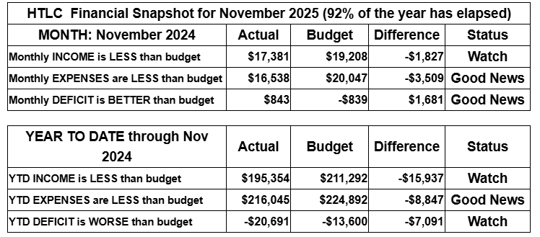
November giving improved over that of October, but still is short for the year to date. Expenses remain under control, but we rely on strong giving in December to maintain stability and support our ministries. Gifts above and beyond regular giving will help us build a growing, healthy church. Thank you for your generosity.
Thank you for supporting our ministry! Chris Foard, Treasurer

Worship Volunteer Schedule
Date | Asst. Min | Usher | Sacristan | Lector | Counter
December 7 | Chris Foard | Keith Bennett | Carol Rosen | Emily Kaster | Foss/Foard
December 14 | Elaine Bradford | Kathy Caputo | Nancy Poole | Molly Foard | Bohner/Volk
December 21 | Charlie Rugg | Gripps | Helga Britton | Bill Spreen | Bradford/Socha
December 28 | Linda Coleman | Dan Grillon | Helga Britton | Cynthia Kazmac | McKenna/Kazmac
January 4 | Keith Bennett | Keith Bennett | Joanne Giordano | Jeff Ridberg | Foss/Coleman

Altar Flowers
December 7th Gripp family in memory of loved ones during the holidays.
December 14th Frances Padron, memor of husband, son and mother. Felix Padron, Reynaldo, Angelica Alvarez.

Coffee Hour
November 30th Pat & Jeff Pienkos
December 7th Poole
December 14th The Doyle’s
Debember 21st Christmas brunch
December 28th
Please consider siging up of a coffee hour. Recruit some friends to help. Thank you!

ANNOUNCEMENTS Thank you! To all who consistently support our church and ministries through your time, talent, and treasure. Please help us grow by inviting your friends and family to worship and events. You are what makes Holy Trinity a wonderful church family!

Stay in touch! Please visit our church website, www.htlcredbank.org for updates and information. You can also find us on Facebook and view services online. The office is open from 9am to 2pm, Monday to Thursday.

100 Anniversary Committee- If you are interested in being a part of the committee to help plan the 100th anniversary celebration of HTLC in 2028, please sign up in the red book. All are welcome! Also, the committee will be looking for photos and documents of HTLC throughout the years. If you have anything to share, please bring them to the church and marked envelopes or email electronic copies to the church office.

Photo Directory- Day one of photos was a success! After worship, we will be taking photos for an updated Holy Trinity photo directory. Casey H. and her boyfriend Bart (professional photographer!) will have a station set up during coffee hour, so please stop by for an updated head shot! Photos will be taken on the following dates: 11/23, 12/7, 12/14, 12/21. Please see Casey H. or Elaine B. with any questions.

Name Tag Sundays: On the first Sunday of each month, names tags and markers will be at each entrance of the sanctuary. Please fill out a tag and wear one for worship and for coffee hour to welcome visitors and help newcomers put names to faces.
Choir The Holy Trinity Choir welcomes our singers back for a preparation rehearsal on Sunday, September 7th at 9am in the church hall. All are welcome to join us in song as often as you are able. Choir meets each Sunday at 9am to practice and prepare our music. Join us and help us grow by spreading the word about the HTLC Choir!

Blood drive Tuesday January 6, 2026, noon to 6 pm

On Tuesday, January 6, 2026 we will be hosting a blood drive here at Holy Trinity from Noon to 6pm. Donors, mark your calendars! If you cannot donate, please recruit from among your friends and family. This day marks Epiphany, ending the Christmas season, so let's give a final gift -- of life! For an appointment, please scan QR Code

Or sign-up at: www.nybc.org/drive Use Sponsor Code 70422

Quilting- The Quilters need gently used any bed sheets of any size! Please leave any donations in the quilters closet in Fellowship Hall. Thank you!

Weekly Quilting on Wednesdays at 9:30. Bring your lunch and enjoy some fellowship at noon. All are welcome. There will be no quilting on Wednesday September 24 due to the garage sale set up.

Evening Quilting Evening Quilting –
Please share this information . This is an important ministry that helps so many. It’s very easy and you don’t need to know how to sew. We have a great time socializing too! We will meet:
Oct. 15, Nov 19, Dec 17 At 6:00 PM. Note: If we have to cancel I will send an email. Please let me know only if you can come. Contacts: Pat Pienkos 732-513-9615 Debbie Yetka 908-461-4084 Looking forward to seeing you all!

Bagels and Bible- Bagels and Bible will be meeting on the second and fourth Saturdays of the month at 8:30. The group will meet in the Parish House.

Social Ministry
CPC Thanksgiving Dinner
We celebrated another joyful Thanksgiving dinner with 45 CPC clients and staff the Wednesday before Thanksgiving! Thank you to all the volunteers that helped make this happen and run smoothly including shopping, decorating, setting up, cooking, serving, and clean up! With the help of Thrivent in Action grant money, we were able to provide this dinner which means so much to the gracious CPC clients. HTLC has been hosting this dinner since 1983 and we hope to keep the tradition going!

*Year-round collections will continue for food items for Lunch Break. There is a sign-up sheet in the red book for those who can help drop these items to Lunch Break.
*We will also collect adult men's socks to periodically drop at the Red Bank Warminq Center.
*For those interested in the Heartwarminq Center — the new women's shelter is adjacent to the First Baptist Church of Red Bank at 90 Maple Ave. You can follow up on this mission through their website - https://www.thefeastnj.org- On this site, they also include wish list items that can be purchased through amazon. We will be exploring purchasing some of these through a Thrivent card. If you want to purchase on your own, you can leave items at church, and the Social Ministry will deliver them.

Pastoral Care and Prayer... We are here to care for and pray! Please contact the office to add or adjust prayer requests. If you or someone you know needs pastoral care, please contact the office and Pastor Mack!

THANK YOU for supporting and sustaining our church and ministries! All are welcome here! Please invite your family and friends to worship with us! Find us online at www.htlcredbank.org
