Holy Trinity Lutheran Church
150 River Road Red Bank, NJ 07701
Church Office: (732) 741-9241 Fax: (732) 741-9577
email: holytrinitychurch4@verizon.net
Website: htlcredbank.org
Pastor: Rev. John Mack, Jr.
Cell: (336)-392-5839
Minister of Music: Peter Isherwood
Parish Administrator: Deanna Vergari
Council President: Cynthia Kazmac

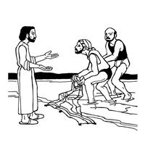

January 25, 2026

Third Sunday after Epiphany

Introduction

Jesus begins his public ministry by calling fishers to leave their nets and follow him. In Jesus the kingdom of God has come near. We who have walked in darkness have seen a great light. We see this light most profoundly in the cross—as God suffers with us and all who are oppressed by sickness, sin, or evil. Light dawns for us as we gather around the word, the font, and the holy table. We are then sent to share the good news that others may be “caught” in the net of God’s grace and mercy.

Welcome & Announcements (Please remember to silence your cell phone!)

Prelude (We prayerfully prepare our hearts and minds to worship!)

+ GATHERING +

Confession and Forgiveness
All may make the sign of the cross, the sign that is marked at baptism, as the presiding minister begins.
P:Blessed be the holy Trinity, ☩ one God,
the Creator of heaven and earth,
the Word who spoke life into being,
the Wind stirring the waters.
C:Amen.
P:Let us turn in confession to the one who knows us completely.
Silence is kept for reflection.
Mighty God, lover of justice,
C:you call us to life in community,
but we have served our own interests
at the expense of our neighbors.
We have sown deceit where honesty was needed.
We say the right words,
but our hearts are far from you.
Turn us to seek your face.
Knit us together and give us the mind of Christ,
that we may do justice, love mercy,
and walk humbly with you, our God.
Amen.
P:The former things have passed away,
and new things God now declares:
Like a spring of water that never fails,
God covers you in the righteousness of Christ,
and forgives your sin in ☩ Jesus’ name.
May the Spirit give you strength to live for others,
and bless you with the gift of peace.
C:Amen.

*Gathering Hymn ELW 314 Arise, Your Light Has Come
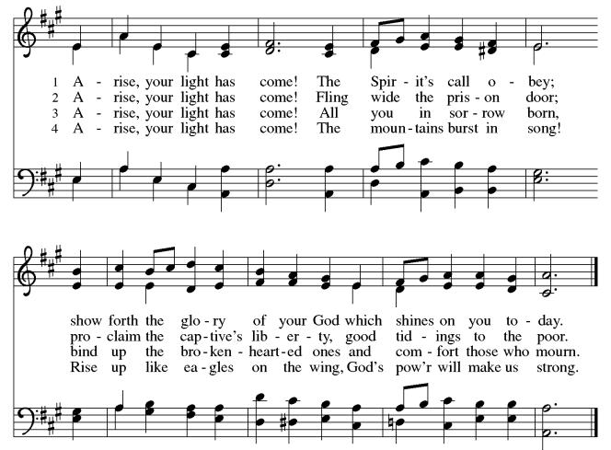

*Pastoral Greeting

P: The Grace of our Lord Jesus Christ, the love of God, and the communion of the Holy Spirit be with you all.

C: And also with you!

Hymn of Praise

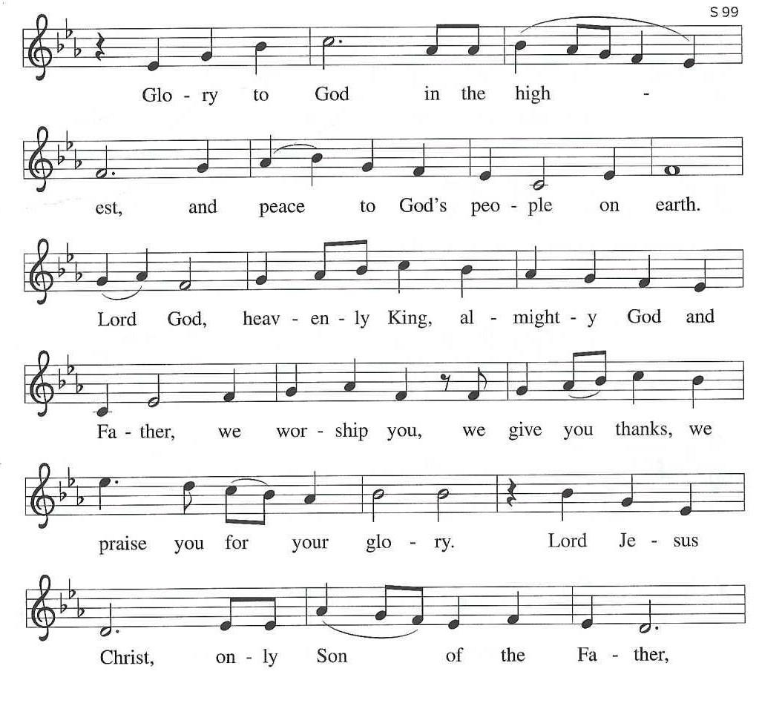

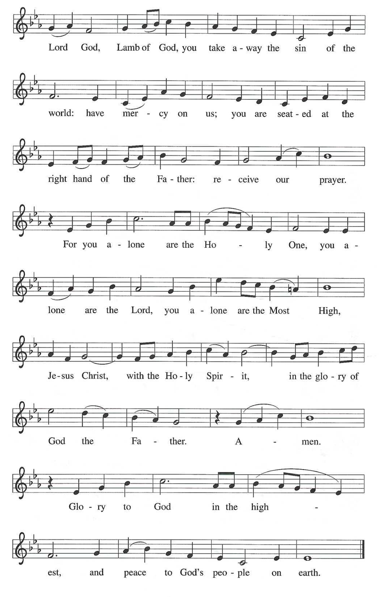

*Prayer of the Day
P: Lord God, your lovingkindness always goes before us and follows after us. Summon us into your light, and direct our steps in the ways of goodness that come through the cross of your Son, Jesus Christ, our Savior and Lord.
C: Amen!

Children’s Message

+WORD+

First Reading Isaiah 9:1-4
The northern tribes of Zebulun and Naphtali experienced the gloom of defeat by Assyrian military forces, but they are assured that their condition will be reversed when God makes a light-filled appearance. The joy they will experience will resemble celebrations of great harvests, because God will deliver them from everything that diminishes or oppresses them.

¹ There will be no gloom for those who were in anguish. In the former time [the Lord] brought into contempt the land of Zebulun and the land of Naphtali, but in the latter time he will make glorious the way of the sea, the land beyond the Jordan, Galilee of the nations.
² The people who walked in darkness
have seen a great light;
those who lived in a land of deep darkness—
on them light has shined.
³ You have multiplied exultation;
you have increased its joy;
they rejoice before you
as with joy at the harvest,
as people exult when dividing plunder.
⁴ For the yoke of their burden
and the bar across their shoulders,
the rod of their oppressor,
you have broken as on the day of Midian.

Psalm: Psalm 27:1, 4-9
The Lord is my light and my salvation. (Ps. 27:1)

¹ The Lord is my light and my salvation; whom then | shall I fear?
The Lord is the stronghold of my life; of whom shall I | be afraid?
⁴ One thing I ask of the Lord; one | thing I seek;
that I may dwell in the house of the Lord all the days of my life; to gaze upon the beauty of the Lord and to seek God | in the temple.
⁵ For in the day of trouble God will | give me shelter,
hide me in the hidden places of the sanctuary, and raise me high up- | on a rock.
⁶ Even now my head is lifted up above my enemies | who surround me.
Therefore I will offer sacrifice in the sanctuary, sacrifices of rejoicing; I will sing and make music | to the Lord.
⁷ Hear my voice, O Lord, | when I call;
have mercy on me and | answer me.
⁸ My heart speaks your message— | “Seek my face.”
Your face, O Lord, | I will seek.
⁹ Hide not your face from me, turn not away from your ser- | vant in anger.
Cast me not away—you have been my helper; forsake me not, O God of | my salvation.

Second Reading: 1 Corinthians 1:10-18
Paul calls on the Corinthians to end their dissensions and share the unified outlook of the gospel. Discord arises when we forget that we belong not to human leaders or institutions but to Christ. Indeed, the unifying word of the cross of Christ is the center of the gospel and the power of God’s salvation.

¹⁰ Now I appeal to you, brothers and sisters, by the name of our Lord Jesus Christ, that all of you be in agreement and that there be no divisions among you but that you be knit together in the same mind and the same purpose. ¹¹ For it has been made clear to me by Chloe’s people that there are quarrels among you, my brothers and sisters. ¹² What I mean is that each of you says, “I belong to Paul,” or “I belong to Apollos,” or “I belong to Cephas,” or “I belong to Christ.” ¹³ Has Christ been divided? Was Paul crucified for you? Or were you baptized in the name of Paul? ¹⁴ I thank God that I baptized none of you except Crispus and Gaius, ¹⁵ so that no one can say that you were baptized in my name. ¹⁶ I did baptize also the household of Stephanas; beyond that, I do not know whether I baptized anyone else. ¹⁷ For Christ did not send me to baptize but to proclaim the gospel—and not with eloquent wisdom, so that the cross of Christ might not be emptied of its power.
¹⁸ For the message about the cross is foolishness to those who are perishing, but to us who are being saved it is the power of God.
Gospel Acclamation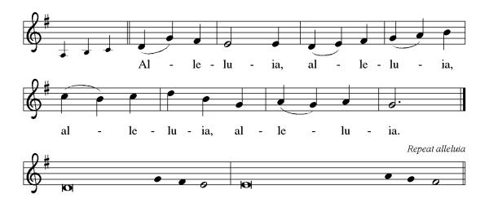

P: The Holy Gospel According to St. Matthew 4th Chapter
C: Glory to You O Lord!

Gospel: Matthew 4:12-23
Jesus begins his public ministry shortly after John the Baptist is imprisoned by Herod. He proclaims the nearness of God’s reign and calls four fishermen to be his first disciples.

¹² Now when Jesus heard that John had been arrested, he withdrew to Galilee. ¹³ He left Nazareth and made his home in Capernaum by the sea, in the territory of Zebulun and Naphtali, ¹⁴ so that what had been spoken through the prophet Isaiah might be fulfilled:
¹⁵ “Land of Zebulun, land of Naphtali,
on the road by the sea, across the Jordan, Galilee of the gentiles—
¹⁶ the people who sat in darkness
have seen a great light,
and for those who sat in the region and shadow of death
light has dawned.”
¹⁷ From that time Jesus began to proclaim, “Repent, for the kingdom of heaven has come near.”
¹⁸ As he walked by the Sea of Galilee, he saw two brothers, Simon, who is called Peter, and Andrew his brother, casting a net into the sea—for they were fishers. ¹⁹ And he said to them, “Follow me, and I will make you fishers of people.” ²⁰ Immediately they left their nets and followed him. ²¹ As he went from there, he saw two other brothers, James son of Zebedee and his brother John, in the boat with their father Zebedee, mending their nets, and he called them. ²² Immediately they left the boat and their father and followed him.
²³ Jesus went throughout all Galilee, teaching in their synagogues and proclaiming the good news of the kingdom and curing every disease and every sickness among the people.

P: The Gospel of the Lord
C: Praise to you, O Christ!

Sermon

*Hymn of the Day ELW 843 Praise the One Who Breaks the Darkness
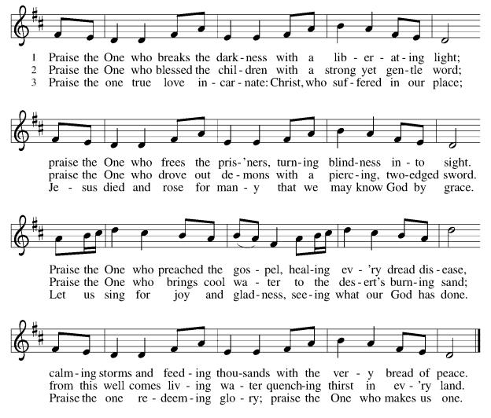

*Prayers of Intercession
As God’s beloved children united in Christ, let us pray for the church, the whole human community, and the well-being of the earth, our home.
A brief silence.
Holy One, you entrust the message of the cross and the mission of the gospel to the church in every land. Guide the newly baptized and deepen the faith of all who follow Christ. Merciful God,
C:receive our prayer.
Holy Creator, you lavish creation with splendor, and we praise you for the gift of life. Teach us to live as wise stewards, sharing the earth’s resources with all inhabitants of this garden planet. Merciful God,
C:receive our prayer.
Holy Judge, your power is love, and you judge the nations by the measure of Christ. Free any who are unjustly accused or wrongly condemned. We pray for those in authority (local and national officials may be named). Merciful God,
C:receive our prayer.
Holy Lover, you care for vulnerable young children, frail elders, and any who are sick (especially). We pray for all who are affected by natural disasters (individuals or situations may be named). Provide for their needs and relieve their suffering. Merciful God,
C:receive our prayer.
Holy Giver, you gather, forgive, and shape us as disciples of Christ. Nurture in us a spirit of patience and respect, that we may love one another as you love us. Merciful God,
C:receive our prayer.
Here other intercessions may be offered.
Holy Savior, you free us from the power of death. Lead and guide us until we come at last into the communion of all your saints in light. Merciful God,
C:receive our prayer.
Confident that the Holy Spirit receives our prayers and answers us, we commend all for whom we pray to God’s loving-kindness made known to us in Christ Jesus our Savior. C: Amen.
Offering (Thank you for your support for our ministry!)
*Doxology ELW 306 Come, Beloved of the Maker (v.5)(Please stand and join in singing as we share our gifts!)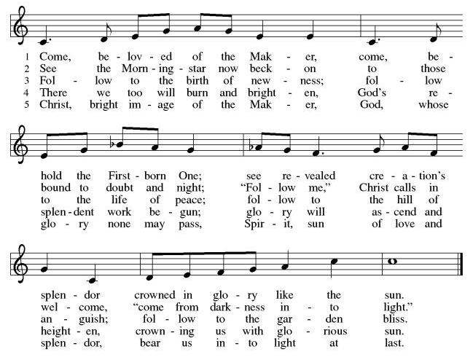

*Offering Prayer
A: God of majesty,
C: no eye has seen, no ear has heard
what you have prepared for those who love you,
yet in this meal you reveal the wideness of your mercy.
Use what we have gathered
to feed us with the reign of God come near,
Jesus Christ, our Savior and Lord.
Amen!

+MEAL+
*Great Thanksgiving
P: The Lord be with you.
C: And also with you.

P: Lift up your hearts.
C: We lift them to the Lord.

P: Let us give thanks to the Lord our God.
C: It is right to give our thanks and praise.

P: It is indeed right, our duty and our joy,
that we should at all times and in all places
give thanks and praise to you, almighty and merciful God,
through our Savior Jesus Christ.
By the leading of a star he was shown forth to all nations;
in the waters of the Jordan you proclaimed him your beloved Son;
and in the miracle of water turned to wine he revealed your glory.
And so, with all the choirs of angels,
with the church on earth and the hosts of heaven,
we praise your name and join their unending hymn:

*Sanctus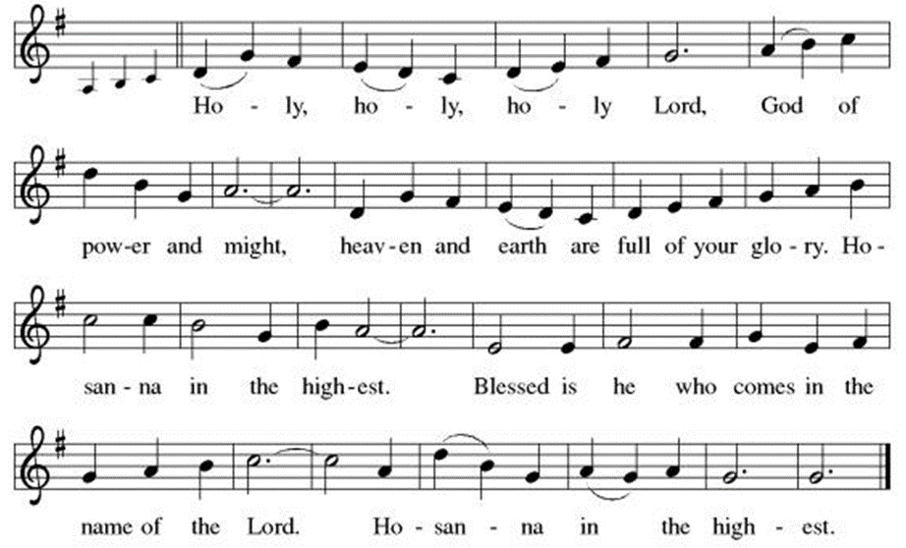

*Eucharistic Prayer
P:Holy God, mighty Lord, gracious Father:
Endless is your mercy and eternal your reign.
You have filled all creation with light and life;
heaven and earth are full of your glory.

We praise you for the grace shown to your people in every age:
the promise to Israel,
the rescue from Egypt,
the gift of the promised land,
the words of the prophets;
and, at this end of all the ages, the gift of your Son,
who proclaimed the good news in word and deed
and was obedient to your will, even to giving his life.

In the night in which he was betrayed,
our Lord Jesus took bread, and gave thanks;
broke it, and gave it to his disciples, saying:
Take and eat; this is my body, given for you.
Do this for the remembrance of me.

Again, after supper, he took the cup, gave thanks,
and gave it for all to drink, saying:
This cup is the new covenant in my blood,
shed for you and for all people for the forgiveness of sin.
Do this for the remembrance of me.

For as often as we eat of this bread and drink from this cup,
we proclaim the Lord’s death until he comes.
C: Christ has died. Christ is risen. Christ will come again.

P:Therefore, O God, with this bread and cup
we remember the life our Lord offered for us.
And, believing the witness of his resurrection,
we await his coming in power
to share with us the great and promised feast.
C:Amen. Come, Lord Jesus.

P:Send now, we pray, your Holy Spirit,
that we who share in Christ’s body and blood
may live to the praise of your glory
and receive our inheritance with all your saints in light.
C:Amen. Come, Holy Spirit.

P:Join our prayers with those of your servants
of every time and every place,
and unite them with the ceaseless petitions of our great high priest
until he comes as victorious Lord of all.
Through him, with him, in him,
in the unity of the Holy Spirit,
all glory and honor is yours, almighty Father,
now and forever.
C:Amen.

*THE LORD’S PRAYER
Our Father, who art in heaven,
hallowed be thy name,
thy kingdom come,
thy will be done,
on earth as it is in heaven.
Give us this day our daily bread;
and forgive us our trespasses,
as we forgive those
who trespass against us;
and lead us not into temptation,
but deliver us from evil.
For thine is the kingdom,
and the power, and the glory,
forever and ever. Amen.
*Lamb of God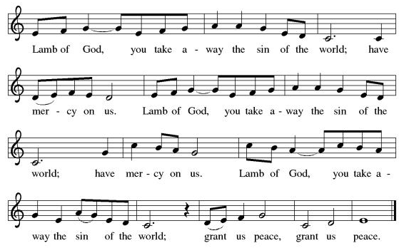

Spiritual Communion Prayer
P: Let us pray for the communion of all present here, those viewing our service virtually, those in our hearts and in our world.
C: Lord Jesus, I believe you are truly present in the Sacrament of Holy Communion. When I cannot receive Communion, I pray that you come into my heart. I know that nothing in Heaven or on earth can separate me from your love. Amen.

Invitation to Communion
P: Here is the Lamb of God who takes away the sin of the world!
Come to the table; taste and see.
C: Thanks be to God!

(All are invited to the communion rail following the guidance of the ushers. Communion will be shared through the host and individual cups. If you would like communion but are unable to join us at the rail, please alert the usher!)

Communion Hymns (Please join in singing!)
ELW 496 One Bread, One Body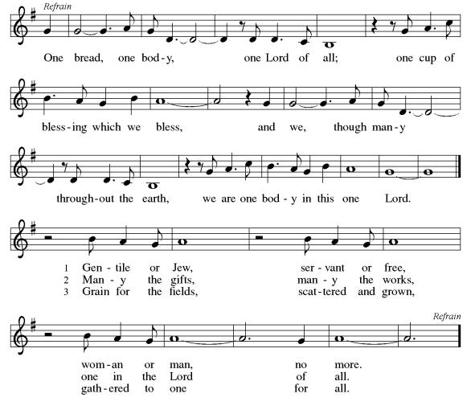

ELW 715 Christ, Be Our Light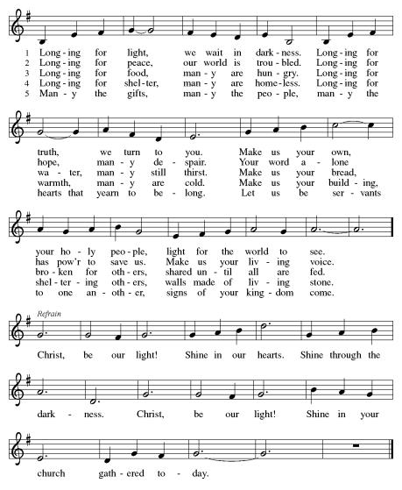

*Prayer after Communion
A: Radiant God,
we have seen your glory in the face of Jesus Christ.
In the sacrament of his body and blood
you have drawn us to your heart.
Send us from this table with delight,
that our lives may reflect the beauty of your love,
and bear witness to all we have seen and heard,
through Jesus Christ, our Savior and Lord. C: Amen.
Scouting Prayer
Bless the work of Scouting, in this place and around the world, that, through its efforts, the young may, like our Lord, increase in wisdom and in stature, and in favor with you and all people.
C:Amen

+Sending+

*Blessing
P: May the triune God,
who has put a new song in your mouth
and tuned your heart for praise
☩ bless you now and forever. C: Amen!

*Sending Hymn ELW 576 We All Are One in Mission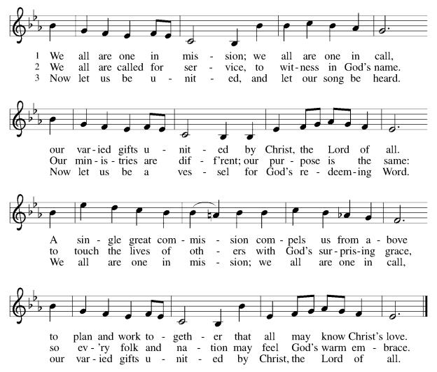

*Dismissal
A: Go in peace. Do justice. Love mercy.
C: Thanks be to God!

Postlude

Copyright © 2020 Augsburg Fortress. All rights reserved. Reprinted by permission under Augsburg Fortress Liturgies Annual License #SB106907. New Revised Standard Version Bible, Copyright © 1989, Division of Christian Education of the National Council of the Churches of Christ in the United States of America. Used by permission. All rights reserved. Revised Common Lectionary, Copyright © 1992 Consultation on Common Texts, admin Augsburg Fortress. Used by permission.

Treasurer’s Report
HTLC Financial Snapshot - December 2025
Category | Actual | Budget | +/- vs Budget | Status
December Income | $20,559 | $19,208 | $1,351 | On Track
December Expenses | $20,507 | $20,672 | -$165 | On Track
December Result | $53 | -$1,464 | $1,516 | On Track
YTD Income | $215,914 | $230,500 | -$14,586 | Attention
YTD Expense | $243,005 | $245,564 | -$2,559 | On Track
YTD Result | -$27,091 | -$15,064 | -$12,027 | Attention

While expense control was strong throughout the year,. income did not meet expectations, creating a larger deficit than planned. However, we are certain that the generosity andthe commitment of the people of Holy Trinity will make great things happen in 2026!
Thank you for supporting our ministry! Chris Foard, Treasurer

Worship Volunteer Schedule
Date | Asst. Min | Usher | Sacristan | Lector | Counter
January 11 | Chris Foard | Kathy Caputo | Sherry Lee | Rosemary Lane | Socha/Foard
January 18 | Elaine Bradford | Dan Grillon | Carol Rosen | Emily Kaster | Bohner/Volk
January 25 | Charlie Rugg | Bennetts | Pat Pienkos | Jeff Ridberg | Bradford/Giordano
February 1 | Linda Coleman | Kathy Caputo | Sherry Lee | Cynthia Kazmac | Carleo/Csernica

Coffee Hour- Council Members
Altar Flowers In memory of Florence Mack (mother) Love.

ANNOUNCEMENTS Thank you! To all who consistently support our church and ministries through your time, talent, and treasure. Please help us grow by inviting your friends and family to worship and events. You are what makes Holy Trinity a wonderful church family!

Stay in touch! Please visit our church website, www.htlcredbank.org for updates and information. You can also find us on Facebook and view services online. The office is open from 9am to 2pm, Monday to Thursday.

100 Anniversary Committee- If you are interested in being a part of the committee to help plan the 100th anniversary celebration of HTLC in 2028, please sign up in the red book. All are welcome! Also, the committee will be looking for photos and documents of HTLC throughout the years. If you have anything to share, please bring them to the church and marked envelopes or email electronic copies to the church office.

Name Tag Sundays: On the first Sunday of each month, names tags and markers will be at each entrance of the sanctuary. Please fill out a tag and wear one for worship and for coffee hour to welcome visitors and help newcomers put names to faces.

Congregational Meeting January 25, 2026 if postponed due to weather the new date will be February 1, 2026

Sunday School in the New Year, we will continue to study stories and lessons from the Old Testament beginning with Jacob. Kids will love the crafts, songs and games that accompany each lesson.
The following dates there will be Sunday School:
Jan- 11 and 25, Feb- 8 and 22, March- 1, 15 and 29*Easter Egg Hunt!
April- 12 and 26, May- 3, 17 and 31, June- 7 and 14
As was done in the fall, there will be opportunities to volunteer as SS lead teacher. A signup will be emailed out shortly and will also be posted in the red binder. Consider signing up! All lesson materials will be supplied and laid out and a leader guide will be emailed to volunteers approximately 1 week in advance. Blessings for a wonderful 2026!~Lauren

Trivia Night!! Mark your calendars! Plan for a fun night at Holy Trinity on Feb. 28 at 5pm for great food and trivia. We have an International theme, so we ask you to bring a pot luck dinner item showing your ethnic heritage. There is a sign up sheet for your convenience.
You don't have to be another Ken Jennings---this is just for fun. See you then!

Choir The Holy Trinity Choir welcomes our singers back for a preparation rehearsal on Sunday, September 7th at 9am in the church hall. All are welcome to join us in song as often as you are able. Choir meets each Sunday at 9am to practice and prepare our music. Join us and help us grow by spreading the word about the HTLC Choir!

Quilting- The Quilters need gently used any bed sheets of any size! Please leave any donations in the quilters closet in Fellowship Hall. Thank you!

Quilters Need Help
If anyone is traveling through Mechanicsville, PA, and can add a few extra minutes to your trip, the warehouse for shipping quilts, school kits, etc is located directly off one of the exits.
We accumulate many quilts throughout the year and we would appreciate sending some quilts with you to deliver. Any questions, please call Sherry Lee or Elaine Theophall.

Weekly Quilting on Wednesdays at 9:30. Bring your lunch and enjoy some fellowship at noon. All are welcome. There will be no quilting on Wednesday September 24 due to the garage sale set up.

Evening Quilting Evening Quilting –
Please share this information . This is an important ministry that helps so many. It’s very easy and you don’t need to know how to sew. We have a great time socializing too! We will meet: Jan. 21, Feb. 18, March 18 at 6:00 PM. Note: If we have to cancel I will send an email. Please let me know only if you can come. Contacts: Pat Pienkos 732-513-9615 Debbie Yetka 908-461-4084 Looking forward to seeing you all!

Social Ministry
*Year-round collections will continue for food items for Lunch Break. There is a sign-up sheet in the red book for those who can help drop these items to Lunch Break.
*We will also collect adult men's socks to periodically drop at the Red Bank Warminq Center.
*For those interested in the Heartwarminq Center — the new women's shelter is adjacent to the First Baptist Church of Red Bank at 90 Maple Ave. You can follow up on this mission through their website - https://www.thefeastnj.org- On this site, they also include wish list items that can be purchased through amazon. We will be exploring purchasing some of these through a Thrivent card. If you want to purchase on your own, you can leave items at church, and the Social Ministry will deliver them.

Pastoral Care and Prayer... We are here to care for and pray! Please contact the office to add or adjust prayer requests. If you or someone you know needs pastoral care, please contact the office and Pastor Mack!

THANK YOU for supporting and sustaining our church and ministries! All are welcome here! Please invite your family and friends to worship with us! Find us online at www.htlcredbank.org

